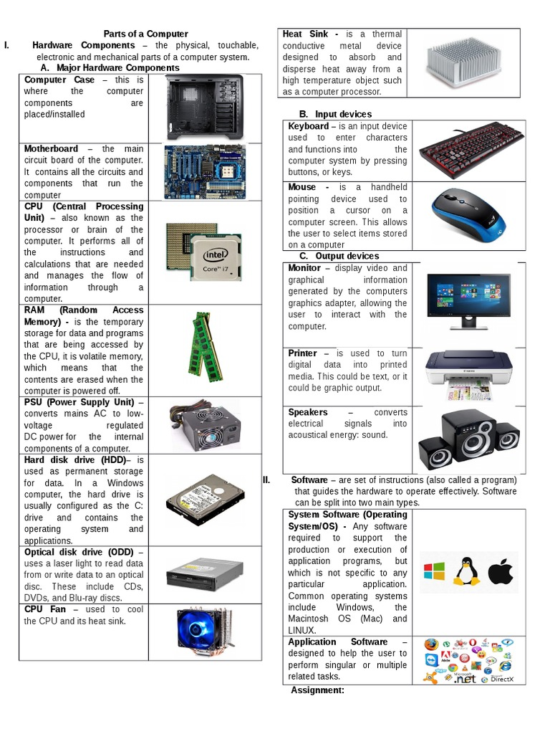
COMPUTER HARDWARE PARTS AND THEIR USES

